Setting up postman -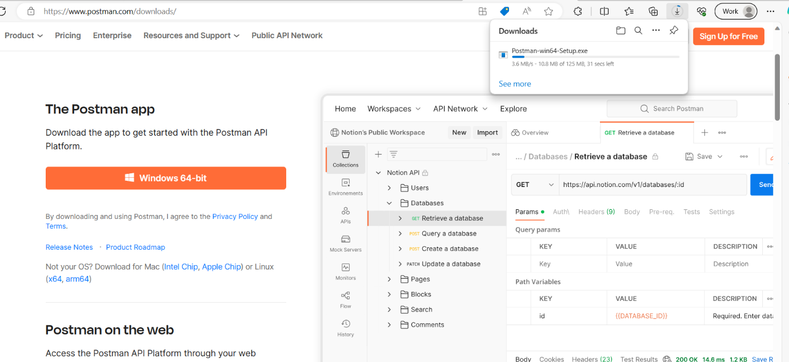

Searching in chrome <https://www.postman.com>

And download the postman in the local machine.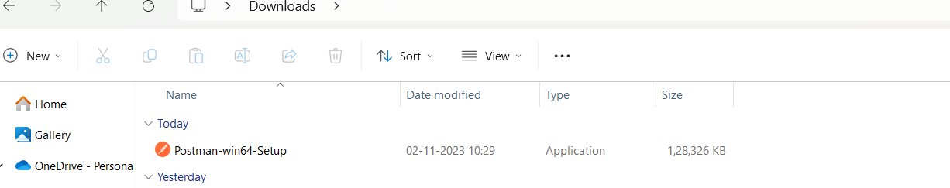

And

Click on creating account

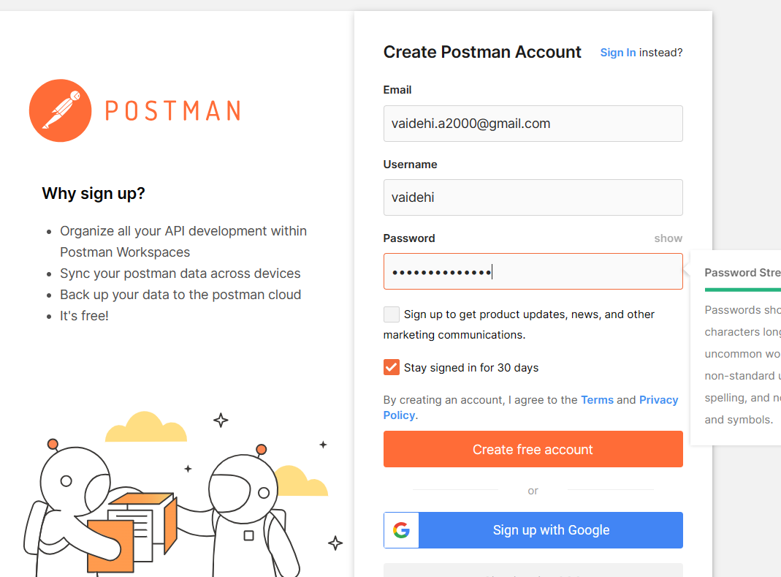

Then sign up the post man.

